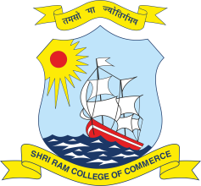 | SHRI RAM COLLEGE OF COMMERCE  University of Delhi, Maurice Nagar, Delhi – 110 007  Website: www.srcc.edu Phone: 27667905, 27666519

Date: 18.08.2020

Renovation of College Auditrium Project
(Tehnical Bids Qualification and Opening of Financial Bids)

The following parties have qualified their Technical Bids for the Renovation of College Auditorium.

- M/s Rakesh Kumar Engineers and Contractors
- M/s Specific Project
- M/s Apex HVAC Services Pvt. Ltd.

The Financial Bids for Renovation of College Auditoirum shall be opend on Wednesday, 19.08.2020 at 1.00 pm in the Staff Room, Shri Ram College of Commerce. The above parties who have qualified their Technical Bids are advised to remain present at the time of opening of Fiancial Bids as per the above schedule.

PRINCIPAL

